**My Opinion T-Chart**

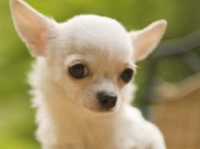 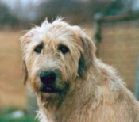

|  |  |
| --- | --- |
| **Chihuahua** | **Irish Wolfhound** |
| **Eyes:** | **Eyes:** |
| **Ears:** | **Ears:** |
| **Fur:** | **Fur:** |
| **Fur Color:** | **Fur Color:** |
| **Size:** | **Size:** |